LOW CODE
EXPERIMENT-1
AKILAA M 240701027

Comparative study of low-code development versus traditional application development approaches.

AIM
To study and compare the traditional application development approach with the low-code application development approach based on development stages, coding requirements, development time, cost, flexibility, maintenance, scalability, and ease of application development.

INTRODUCTION TO TRADITIONAL APPLICATION DEVELOPMENT
Traditional application development is a conventional method of developing software applications by manually writing program code using programming languages and development frameworks.
In this approach, developers are responsible for designing the user interface, writing business logic, connecting databases, implementing security, testing the application, deploying it, and maintaining it. The development process generally follows a structured Software Development Life Cycle (SDLC).
Common technologies used in traditional development include HTML, CSS, JavaScript, Java, Python, C#, PHP, SQL, and various application frameworks.
The traditional development approach provides developers with a high level of control and customization. However, it generally requires skilled programmers, more development time, and greater effort for testing and maintenance.
Main characteristics of traditional development:
- Requires manual programming and coding.
- Provides extensive customization and flexibility.
- Developers have complete control over application architecture.

INTRODUCTION TO LOW-CODE DEVELOPMENT
Low-code development is a modern software development approach that allows applications to be created with minimal manual coding. It uses visual development environments, drag-and-drop components, pre-built templates, forms, workflows, and automation tools.
Platforms such as Zoho Creator, Microsoft Power Apps, and OutSystems allow developers and non-programmers to build applications more quickly using visual interfaces.
In low-code development, users can create forms, define database fields, design application pages, and automate business processes using configuration and visual tools. Some platforms also allow developers to add custom code when advanced functionality is required.
Main characteristics of low-code development:
- Requires minimal manual coding.
- Uses drag-and-drop visual components.
- Provides pre-built forms and application components.
- Enables rapid application development.
- Reduces development time and effort.

DIAGRAM FOR STAGES IN TRADITIONAL APPLICATION DEVELOPMENT
The traditional application development process consists of the following major stages:
- Requirement Analysis – Collecting and understanding the requirements of the users.
- System Design – Designing the application structure, database, and user interface.
- Coding / Implementation – Writing the program code and implementing the required features.
- Testing – Testing the application to identify and fix errors.
- Deployment – Making the completed application available for users.
- Maintenance – Updating, improving, and maintaining the application after deployment.
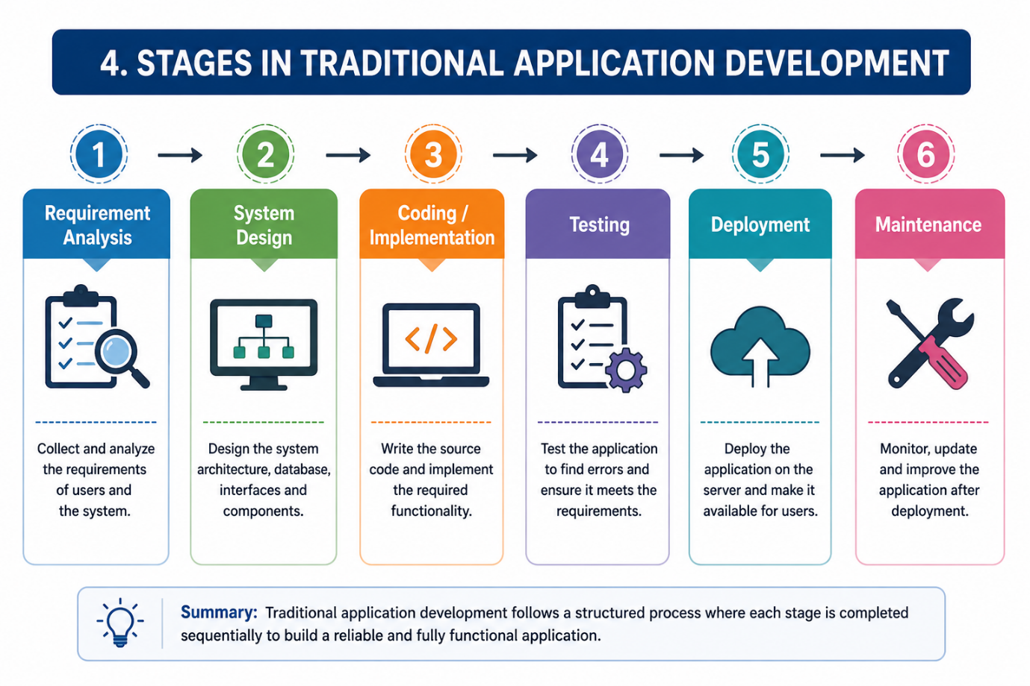

DIAGRAM FOR STAGES IN LOW CODE APPLICATION DEVELOPMENT
The low-code application development process consists of the following steps:

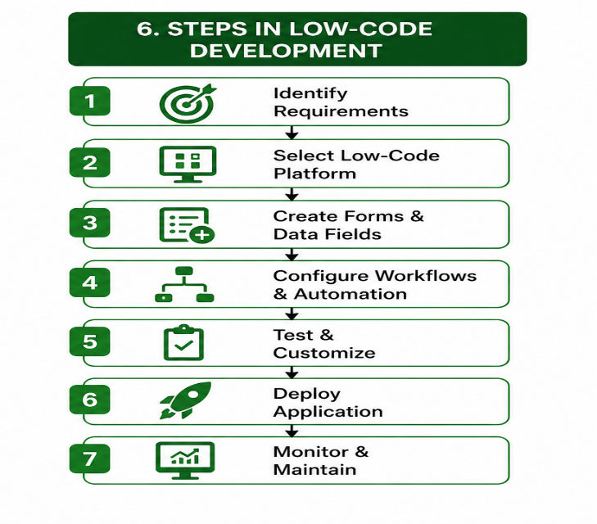

COMPARATIVE ANALYSIS OF TRADITIONAL AND LOW CODE DEVELOPMENT

S.No. | Factor | Traditional Development | Low-Code Development
1 | Coding | Requires extensive manual coding | Requires minimal coding
2 | Development Speed | Takes more time | Faster development
3 | Technical Knowledge | Requires skilled programmers | Can be used by developers and non-developers
4 | User Interface | Created manually using code | Created using visual tools
5 | Database | Requires manual database integration | Often provides built-in database features
6 | Cost | May require higher development cost | Can reduce development cost

RESULT
From the study, it was found that traditional development provides greater flexibility and control but requires more programming knowledge, time, and development effort. Low-code development reduces the need for manual coding and allows applications to be developed quickly using visual tools, pre-built components, and workflow automation.
Therefore, low-code development is an effective approach for rapid application development and business process automation, whereas traditional development is preferred for complex applications requiring extensive customization and complete control over the application architecture.

